CSE-221 (Algorithms)
Assignment 1,2,3,4
Deadline: 29 April, 2024
Assignment 1. (10 points)

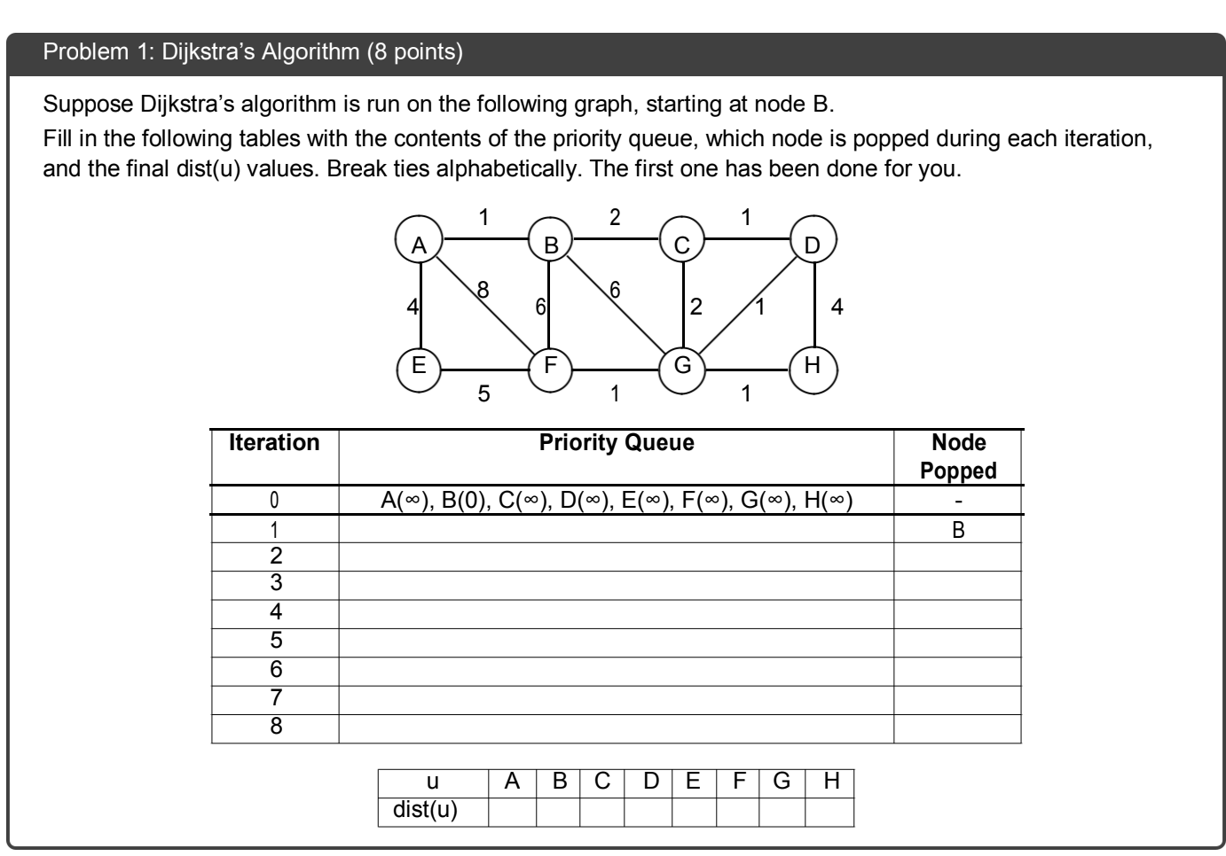

Assignment 2.
In a bustling research conference, there are 10 scientists with unique areas of expertise who wish to collaborate on various projects. Due to time constraints and the complexity of their work, it's not possible for each scientist to collaborate directly with every other scientist. With an important grant application deadline approaching, the scientists must form research teams. The condition for creating these teams is that every scientist in a team must be capable of collaborating with every other member in that team. Calculate the number of possible research teams that can be formed based on this criterion. Each team must be composed of at least two scientists. (10 points)
- The end result will showcase the list of groups and the members of each group. Name the algorithm tailored for this situation. - 2.5 mark
- Show the simulation of your chosen algorithm using the graph below. Write the number of groups that can be formed and the members of each group. - 5 marks
- Those who are incapable of forming a group will be identified as individuals ineligible for conference participation. Identify those people if there are any. - 2.5 mark
- Let’s say we want to find the person who can visit the most houses. Propose an idea to implement this. - 3 marks

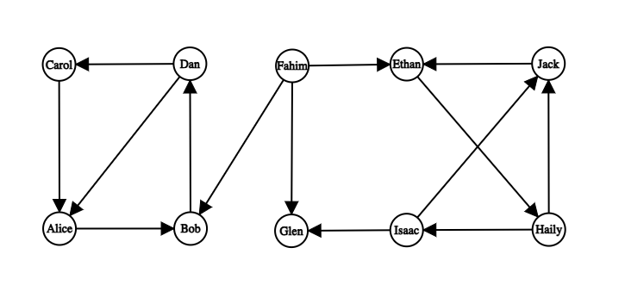
Assignment 3.
The white council once decided to install bidirectional rail tracks to connect several realms of middle earth. Upon their request, the elves and the dwarves devised a plan. The following table lists the tracks that can be constructed. (10 points)
From | To | Length of the track | Construction cost | Construction time
Arnor | Fangorn | 25 | 70 | 80
Arnor | Lindon | 20 | 40 | 30
Arnor | Mirkwood | 30 | 80 | 70
Fangorn | Gondor | 10 | 30 | 40
Fangorn | Lindon | 40 | 90 | 110
Fangorn | Mirkwood | 20 | 60 | 50
Gondor | Harad | 25 | 100 | 90
Gondor | Lindon | 45 | 110 | 100
Gondor | Mirkwood | 30 | 50 | 60
Gondor | Rhun | 40 | 120 | 130
Harad | Mirkwood | 45 | 150 | 180
Mirkwood | Rhun | 25 | 180 | 150
As there is only one engine available for the task, simultaneous construction of multiple tracks is not possible. Going through the plan, the council decided that the following tracks must be constructed.
- Gondor to Lindon
- Arnor to Mirkwood

However, due to a financial crisis, the council wants to connect all the realms with minimum total construction cost. Now answer the following questions.

  - [CO1] Which other tracks should they select for construction? Show a simulation of your procedure. - 5 marks
  - [CO1] Write the total construction cost of the selected tracks. - 1 mark
  - [CO1] Calculate the total construction time required if no two tracks are constructed simultaneously. - 1 mark
  - [CO1] After these tracks have been constructed, what would be the minimum distance of Rhun from all other realms? Just write the distance from each realm. - 3 marks

Assignment 4.
What are the time complexities of DFS, Kosaraju, Dijkstra, Bellman Ford, Kruskal's and explain why. - (10 points)

